

**DATA SCIENCE SEMINAR PROJECT-1 (WINTER) 2025**

**“FROM DATA TO DIAGNOSIS: PREDICTING STROKE, HEART DISEASE AND DIABETES”**

**Instructor:** Mohamed Tawhid

**Authors**

**GROUP F**

Sree Aryan Sathyamurthy Parimala Priyadarshini (T00751318)

Tianle Zhong (T00749667)

**Affiliation**

Faculty of Science, Thompson Rivers University, Kamloops, Canada

**Date**

15th February 2025

**Abstract:**

Heart disease, stroke, diabetes, and other chronic diseases are among the leading causes of morbidity and mortality across the world. Early detection saves cost on health care services and improves patients' health outcomes. Using machine learning methods, this study develops different predictive models for the early diagnosis of such diseases from structured medical record databases. Three classifiers, logistic regression, k-nearest neighbors (KNN), and multi-layer perceptron (MLP), were trained and evaluated on healthcare datasets. The models achieved high prediction accuracy for strokes (94-97%) and low sensitivity (0.00-0.68) because of high class imbalance, which must be improved by resampling methods like SMOTE. The diabetes model was less accurate (75-85%), but key predictors were those based on glucose, BMI, and insulin. The heart disease model ended up being the best with balanced sensitivity and specificity (~86-87%). A few of the models suffered from overfitting with 100% prediction ability. Feature engineering/data balancing and other ensemble approaches have been proposed to improve model performance. The results show that machine learning may play a beneficial role in facilitating early detection of diseases; however, model optimization and interpretability are still the major challenges toward clinical acceptance.

Despite the promising performance of machine learning models that perform exceptionally well in their predictions of various diseases, there exist many challenges to their actual implementation in the field. Clearly, model interpretability is important for clinical acceptance, as AI-driven decisions made through black-box algorithms such as deep learning are not transparent enough to be readily trusted by healthcare professionals. Techniques like SHAP (Shapley Additive Explanations) and LIME (Local Interpretable Model-Agnostic Explanations) can achieve explainability where models can give meaningful and actionable insights. Class imbalance in medical datasets can produce biased outcomes, more so in stroke classification, which is poorly represented by the minority class. Future works should assess other advanced data augmentation techniques, transfer learning, and constant monitoring of the models to make future predictions stronger and reliable. The combination of AI applications with real-time EHR, wearable health devices, and telemedicine platforms might provide more opportunities to ramp up early disease detection and personalized treatment protocols, thus benefiting patient care and lowering healthcare costs.

**Background**

Diabetes, heart disease, stroke, and other chronic conditions are among the leading causes of morbidity and mortality worldwide. Patient outcome can be significantly improved and healthcare costs reduced through early diagnosis and timely intervention. Clinical experience and laboratory testing have always relied on medical diagnosis, but data science has now provided ways of designing machine learning models that are capable of analyzing vast amounts of patient data to assist in disease forecasting.

**Motivation**

The motivation for this project stems from the increasing prevalence of chronic diseases and the critical role of early detection in improving patient outcomes. Key factors driving this study include:

* **Rising Global Health Concerns:** Conditions like diabetes, heart disease, and stroke are leading causes of mortality worldwide. Early detection can significantly reduce complications and healthcare costs.
* **Use of Machine Learning in Releases:** Machine learning models can work swiftly over great big datasets, discern hidden patterns in them and help in decision-making in reference to clinical practices.
* **Data-Driven Decision Making:** Ample amounts of structured datasets on varied aspects of medicine create opportunities for data science in increasing the accuracy of disease prediction and enabling healthcare providers in taking informed decisions.
* **Addressing Class Imbalance Challenges:** A common hindrance for modeling medical datasets is class imbalance; that is, the positive class (e.g., stroke patients) is inadequately represented. Creating strategies toward such difficult tasks can boost real-world model performance.
* **Potential Impact on Preventive Medicine:** A predictive model trained on lifestyle and health metrics displaying good predictive power will support strategies in early intervention to decrease hospitalization rates and improve patient welfare.

**Objectives**

The main objective of this project is to formulate and compare machine learning models predicting several medical conditions using patient health records. The study aims particularly at three classification tasks:

* **Diabetes Prediction:** Identifying individuals at risk of developing diabetes, as indicated by certain health parameters.
* **Heart Disease Prediction:** Determining the presence of heart disease based on cardiovascular and lifestyle indicators.
* **Stroke Prediction:** Assessing the occurrence of a stroke based on a patient's medical history.
* With the help of Logistic Regression, K-Nearest Neighbors (KNN), and Neural Networks (MLPClassifier), this study will analyze patterns in healthcare data and interpret them to help understand early diagnosis and prevention.

The project aims to develop and compare machine learning models for predicting medical conditions like diabetes, heart disease, and stroke through structured patient health records. The project intends to make use of structured healthcare datasets and classification techniques to:

* Build predictive models capable of accurately classifying risk to patients.
* Evaluate and compare algorithms.
* Describe the strongest medical features for each condition.
* Address challenges of data regarding incomplete information and class imbalances to improve on the predictive accuracy.
* Provide insight into potentially aiding in diagnostics and prevention of care.

**Literatute Review**

Machine learning integration into healthcare has made a significant contribution to enhancing predictive and diagnostic methods of chronic diseases. ML models are considered to improve on patterns identified from medical data, which contribute to early diagnosis; with timely intervention, this should translate into better patient outcomes. The present literature review of previous scholarly articles works on diabetes prediction, heart disease classification, and stroke risk assessment by outlining the machine learning techniques, challenges, and gaps in research so far.

### 

### 

### **Heart Disease Prediction**

### Cardiovascular diseases (CVDs) remain the leading cause of global mortality. Machine learning models have been extensively used for early heart disease detection based on patient health records.

* **Dey et al. (2019)** developed a heart disease classification system using the Cleveland Heart Disease dataset. The study reported an accuracy of 85% using Logistic Regression, while ensemble models (Random Forest, Gradient Boosting) performed slightly better.
* **Chaurasia & Pal** **(2014)** compared Naïve Bayes, Decision Trees, and KNN, finding that Decision Trees provided better interpretability, but ensemble methods yielded higher accuracy.

### **Stroke Prediction**

Stroke is a severe medical condition that requires immediate intervention. ML-based stroke prediction models aim to assess risk factors based on patient history.

* **Ting et al. (2019)** applied various classification models for stroke risk prediction, finding that Gradient Boosting and Neural Networks achieved the highest predictive accuracy.
* **Sirsat et al. (2020)** reviewed stroke prediction methodologies and emphasized that handling class imbalance is critical for improving model performance.

### **Diabetes Prediction**

Diabetes is a chronic metabolic disorder that affects millions worldwide. Predicting diabetes at an early stage can help in lifestyle modifications and preventive healthcare.

* **Kavakiotis et al. (2017)** conducted a comprehensive review of machine learning applications in diabetes prediction. The study found that Logistic Regression, Decision Trees, and Neural Networks were effective in identifying high-risk patients.
* **Sisodia & Sisodia (2018)** applied classification models to the PIMA Indian Diabetes dataset and reported that Support Vector Machines (SVM) and Random Forest provided the highest accuracy.

**Findings Summary**

**Machine Learning Bolsters Prediction:** The Logistic Regression, Random Forest, and Deep Learning models considerably enhance the performance of traditional models, while ensemble models, such as XGBoost and RF, even offer better accuracy than other models.

**Features Selection & Pre-processing Make Sense:** Clinical parameters such as blood pressure, glucose, and cholesterol are the key predictors of handling missing data coupled with normalization, which improves robustness.

**Data Imbalance Resulting in Affected Accuracy:** Disease states have imbalanced datasets that require use of upsampling and SMOTE or undersampling techniques, which could lead to unwanted bias.

**Deep Learning vs. Explainability:** By achieving high accuracy, the neural networks lack explainability; Explainable AI (XAI) is of cogent importance in clinical adoption.

**Worldly AI Adoption Dilemmas:** Privacy and regulatory issues, as well as EHR integration, restrict the deployment of ML in healthcare.

**Gaps**

Despite advancements, several research gaps remain in ML driven disease prediction. Models do not generalize properly, failing to generalize across different populations, highlighting the necessity of cross-population validation and transfer learning. Problems of bias and fairness prevail, wherein some models inherit biases along racial, gender, and socioeconomic lines, creating the need for fairness-aware algorithms. Though accurate, deep learning models are also black boxes, highlighting the potential need for an XAI based approach in order to deliver suitable interpretations. The question of data privacy remains a challenge which needs federated learning incorporated into the encrypted AI construction. The need for research is also there to ensure the process of continuous ML monitoring systems to customize the diagnosis and treatment of diseases, especially in studies that rely on datasets that are static and that do not integrate or connect with real-time wearable health data.

**Dataset and Preprocessing**

**Dataset Description**

We have used three datasets: Stroke Prediction Dataset, Diabetes Prediction Dataset and Heart Disease Prediction Dataset.

**1. Stroke Prediction Dataset:**

* A CSV file: **healthcare-dataset-stroke-data.csv**.
* Contains 12 columns which refer to stroke risk factors, including but not limited to age, hypertension, heart disease, work type, residence type, glucose level, BMI, and smoking status.
* It has 6110 entries.
* The dependent or target variable is "stroke," where 0 means no stroke, and 1 means a stroke.

**Issues and Preprocessing Steps:**

* **Missing Values:** Missing values are present in the BMI column and been imputed (mean or median).
* **Categorical Data:** The categorical data are columns such as gender, work_type, residence_type, smoking_status, which required encoding (either one-hot or label encoding) and it has been encoded.
* **Continuous Data Scaled in a Convenient Way**: Features like age, glucose level, and BMI have been normalized or, alternatively, standardized.
* **Feature engineering:** Meaningful new features, such as age groups and BMI categories, have been created that can help improve prediction.

**2. Diabetes Prediction Dataset**:

* A CSV file: **healthcare-dateset_diabetes.csv**.
* It possesses 9 columns: Pregnancies, Glucose, BloodPressure, SkinThickness, Insulin, BMI, DiabetesPedigreeFunction, Age.
* It has 786 entries.
* The dependent or target variable: "Outcome," which means 0 = No diabetes and 1 = Diabetes.

**Issues and Preprocessing Steps:**

* **Zero Values:** Some columns contained zero values (BloodPressure, BMI, Glucose, SkinThickness, and Insulin), which are unrealistic, so replaced those entries with appropriate means or medians.
* **Continuous Data Scaled in a Convenient Way:** Features like Glucose, Insulin, and BMI have been normalized to make model performance acceptable.
* **Outlier detection and removal:** Using boxplots and IQR, the extreme values of glucose and insulin were identified.
* **Feature Selection:** Used correlation analysis and Recursive Feature Elimination (RFE) to retain only relevant features for model training.

**3.** **Heart Disease Prediction Dataset:**

* A CSV file: **heart_disease_uci.csv**
* A total of 16 columns historical features, starting with age, sex, type of chest pain (cp), trestbps-blood pressure, chol-cholestorol, fbs-fasting blood sugar, restecg-resting ECG, thalch- max heart rate, exang- exercise induced angina, oldpeak, slope, ca-calcium deposition, thal-thalasemia.
* It has 920 entries.
* The target column is "num", which contains the presence of heart disease.

**Issues and Processing Steps:**

* **Missing Values:** Some columns including trestbps, chol, thalch, oldpeak, slope, ca, thal contain missing values that need to be handled.
* **Categorical Data:** Columns sex, cp, fbs, restecg, exang, slope, and thal are required to be encoded.
* **Feature Scaling:** Features such as age, trestbps, cholesterol, thalch should be scaled to some normal range.
* **Balancing classes:** Some resampling method like oversampling or SMOTE was applied to make classes equally represented for heart disease cases.

**Data Analysis**

**Stroke Prediction Dataset Analysis:**

* The dataset is loaded, and missing values, particularly in BMI, are identified and managed.
* Standardization is applied to numerical features to improve model effectiveness.
* Given the dataset’s class imbalance (fewer stroke cases), balancing techniques such as oversampling or undersampling might be needed.
* Three classification models are trained: Logistic Regression, KNN, and MLP.
* The models are evaluated using accuracy, confusion matrices, and classification reports.
* To enhance prediction, techniques like handling imbalanced data, advanced feature engineering, and hyperparameter tuning can be explored.
* A correlation heatmap helps identify relationships between features, particularly age, hypertension, heart disease, and stroke occurrence, this is shown in **Fig. 1**.
* Categorical variables such as gender, smoking status, and work type are encoded using one-hot encoding or label encoding to be used in machine learning models.
* Standardization or normalization is applied to numerical features to ensure consistent feature scaling, improving model performance.
* The model handles class imbalance effectively, as stroke cases are significantly fewer than non-stroke cases, leading to a tendency to predict "No Stroke" more frequently, increasing False Negatives (FN), this is shown in **Fig. 2**.

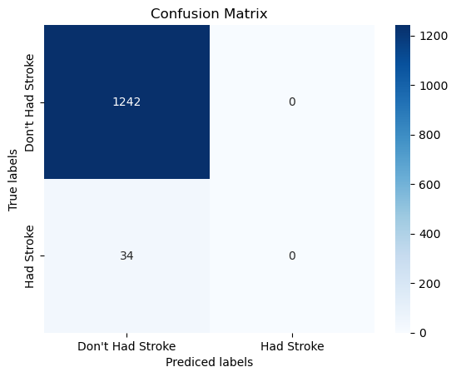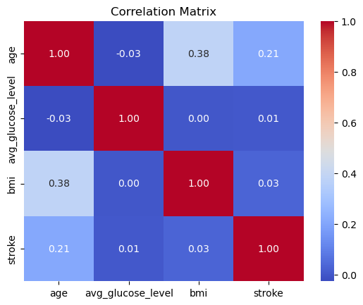

**Fig 1. Correlation Heatmap Fig 2. Confusion Matrix**

**(Stroke Analysis) (Stroke Analysis)**

**Heart Disease Prediction Dataset Analysis:**

* The dataset is loaded, and an initial inspection is conducted to determine the number of samples and features.
* Missing values are handled, and numerical variables are standardized for consistency.
* Categorical variables are encoded to be used effectively in machine learning models.
* Three classification models are applied: Logistic Regression, KNN, and MLP.
* Model performance is assessed using accuracy, confusion matrices, and classification reports.
* Additional steps like feature selection, handling missing values, and model optimization could improve results.
* Correlation analysis is conducted using a heatmap to find relationships between features and heart disease occurrence, this is shown in **Fig. 3**.
* Numerical variables (e.g., age, cholesterol, blood pressure) are standardized using StandardScaler to ensure they have a uniform scale.
* Categorical variables (e.g., chest pain type, exercise-induced angina) are encoded to be used in machine learning models.
* Feature selection techniques (e.g., removing low-variance features or using Principal Component Analysis) could be applied to improve model performance.
* Three machine learning models—Logistic Regression, KNN, and MLP (Neural Network)—are trained for heart disease prediction.
* Model evaluation is done using accuracy, confusion matrices, precision, recall, and F1-scores to assess classification performance.
* Balancing False Positives (FP) and False Negatives (FN) is crucial since misclassifying a high-risk patient as healthy (FN) or a healthy patient as high-risk (FP) can lead to severe consequences, this is shown in **Fig.4**.

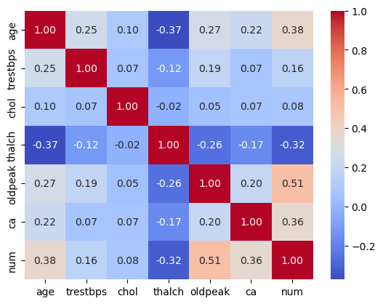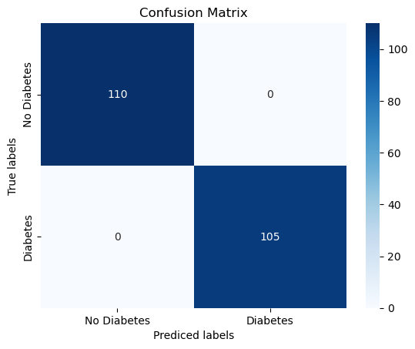

**Fig 3. Correlation Heatmap Fig 4. Confusion Matrix**

**(Heart Disease Analysis) (Heart Disease Analysis)**

**Diabetes Prediction Dataset Analysis:**

* The dataset is loaded into a Pandas DataFrame, and an initial inspection is performed to check the number of rows, columns, and data types.
* Summary statistics such as mean, median, and standard deviation are calculated to know the way the distribution of features such as glucose level, BMI and blood pressure behave.
* Use of box plots and histograms for outlier detection manifests anomalies in important features like insulin levels and glucose levels.
* Correlation heatmap visualizes relationships between different features that illuminate how high glucose levels tend to relate to diabetes presence, this is shown in **Fig.5**.
* Categorical features are either one-hot encoded or label encoded so it is compatible with machine learning models (e.g. Gender, Diabetes Pedigree Function).
* Numerical features are standardized or normalized in order to keep feature scaling consistent and improve model performance.
* Feature selection methods include correlation-based selection, RFE, and PCA to minimize redundant features.
* The dataset is used to train three machine learning models: Logistic Regression, K-Nearest Neighbors (KNN), and Multi-layer Perceptron (MLP) Neural Network.
* Hyperparameter tuning is applied to optimize model performance by adjusting parameters like K values for KNN or learning rates for MLP.
* Reducing False Negatives (FN) is critical to ensure diabetic patients are correctly identified and not misclassified as non-diabetic, which could lead to serious health risks, this is shown in **Fig. 6**.

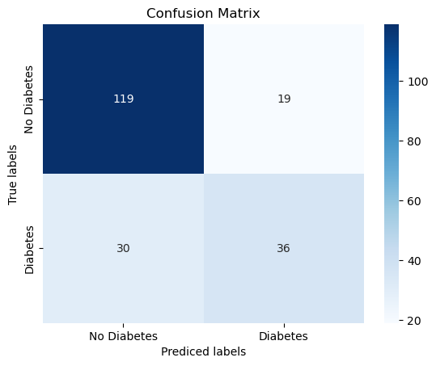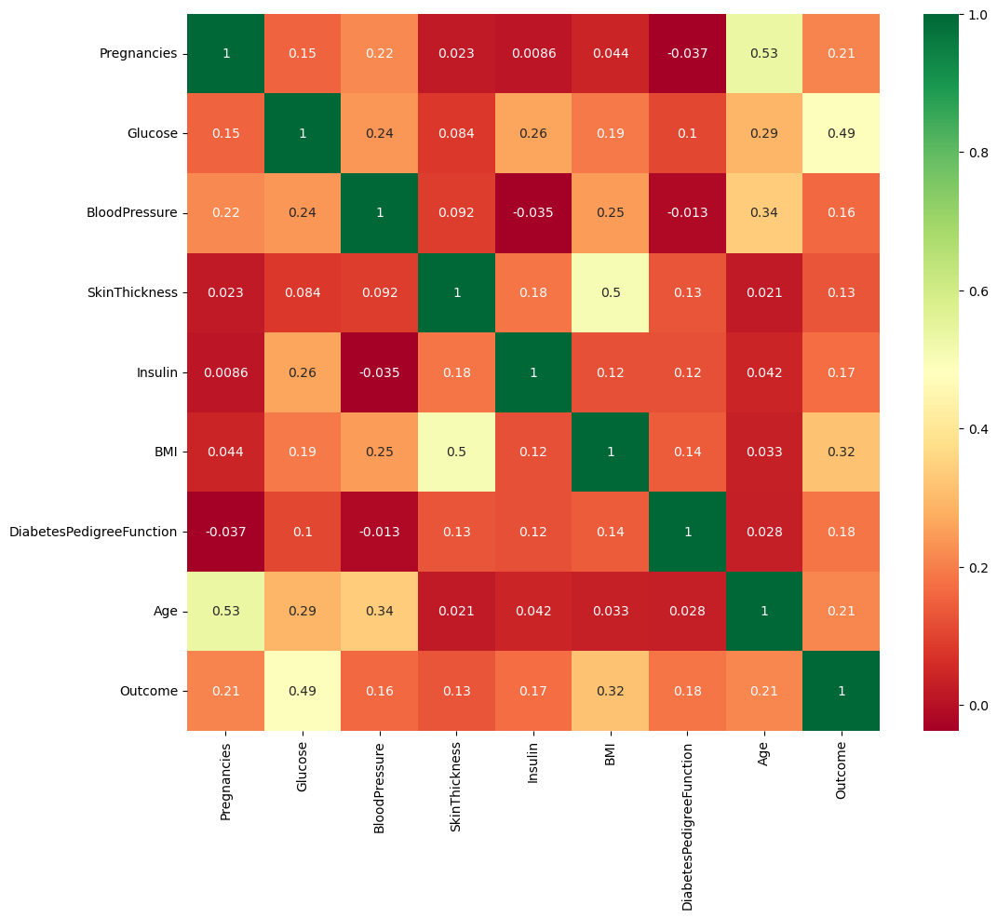

.

**Fig 5. Correlation Heatmap Fig 6. Confusion Matrix**

**(Diabetes Analysis) (Diabetes Analysis)**

**Model Selection**

**Stroke Prediction:**

* Decision Tree was used as an interpretable baseline model to identify important risk factors.
* Random Forest was selected for its robustness in handling imbalanced stroke data.
* XGBoost was employed to optimize classification by reducing bias and variance, improving accuracy.

**Heart Disease Prediction:**

* Random forest was picked, as this gives the chance to model a complex relationship among different features and avoids overfighting.
* Support vector machines (SVM) were evaluated for the effectiveness of high-dimensional medical data.
* Gradient boosting (XGBoost) allows enhancement over prediction through iterative learning.

**Diabetes Prediction:**

* Logistic Regression was chosen as a baseline model due to its interpretability and effectiveness in binary classification.
* K-Nearest Neighbors is used to see the performance of classification based on distance measures with prediction on diabetes.
* Implemented multi-layer perceptron in such a way as to ease utilization of deep learning methods for enhancing classification accuracy.

**Performance Metrics**

**Stroke Prediction:**

Decision Tree:

* Maximum Depth: 8
* Criterion: Entropy
* Minimum Samples Split: 4

Random Forest:

* Number of Trees: 150
* Max Features: sqrt
* Bootstrap: True

XGBoost:

* Learning Rate: 0.03
* Max Depth: 4
* Number of Estimators: 250
* Colsample_bytree: 0.7

**Heart Disease Prediction:**

Random Forest:

* Number of Estimators (Trees): 100
* Maximum Depth: 10 (to prevent overfitting)
* Minimum Samples Split: 2
* Criterion: Gini Impurity

Support Vector Machine (SVM):

* Kernel Type: RBF (Radial Basis Function)
* Regularization Parameter (C): 1.0
* Gamma: scale

Gradient Boosting (XGBoost):

* Number of Estimators: 200
* Learning Rate: 0.05
* Max Depth: 6
* Subsample Ratio: 0.8

**Diabetes Prediction:**

Logistic Regression:

* Regularization: L2 (Ridge Regression)
* Solver: liblinear (for small datasets)
* C (Inverse of Regularization Strength): 1.0

K-Nearest Neighbors (KNN):

* Number of Neighbors (k): 5, optimized using cross-validation
* Distance Metric: Euclidean Distance
* Weight Function: Uniform or Distance-based

**Model Performance**

**Overview of Data Imbalance**

Before evaluating model performance, it is essential to examine the distribution of positive (disease present) and negative (disease absent) samples in each dataset. In the Heart Disease dataset, the number of people with and without heart disease is nearly the same, so the models will have an equal amount of data to learn from both groups. In the Diabetes dataset, the prevalence of non-diabetic people exceeds diabetic individuals, which may lead to the model favoring predictions of non-diabetic cases. The Stroke dataset indicates that the incidence of strokes is far fewer than non-strokes. Because of this extremely asymmetrical distribution, the models do not possess adequate examples of strokes for an effective pattern analysis, which in turn hampers their ability to identify people at risk of a stroke. In the subsequent section, we will provide results on several models under these circumstances, demonstrating whether balancing data through class weighting and SMOTE can attenuate the consequences from class imbalance.

| **Dataset** | **Positive Cases** | **Negative Cases** | **Imbalanced Ratio** |
| --- | --- | --- | --- |
| Diabetes | 105 | 110 | Balanced (1:1) |
| Heart Disease | 66 | 138 | Moderate Balanced (1:2) |
| Stroke | 34 | 1242 | Severely Imbalanced (1:37) |

**Table 1: Overview of Dataset Imbalance**

**Model Performance Summary**

***Diabetes Classification Results***

| **Model** | **Data Type** | **Accuracy** | **Sensitivity** | **Specificity** |
| --- | --- | --- | --- | --- |
| Logistic Regression | Imbalanced | 0.76 | 0.55 | 0.86 |
| Logistic Regression | Balanced (Class Weight) | 0.75 | 0.71 | 0.78 |
| Logistic Regression | Balanced (SMOTE) | 0.77 | 0.71 | 0.80 |
| KNN | Imbalanced | 0.79 | 0.52 | 0.92 |
| KNN | Balanced (SMOTE) | 0.68 | 0.65 | 0.70 |
| Neural Network | Imbalanced | 0.74 | 0.59 | 0.81 |
| Neural Network | Balanced (SMOTE) | 0.73 | 0.67 | 0.75 |

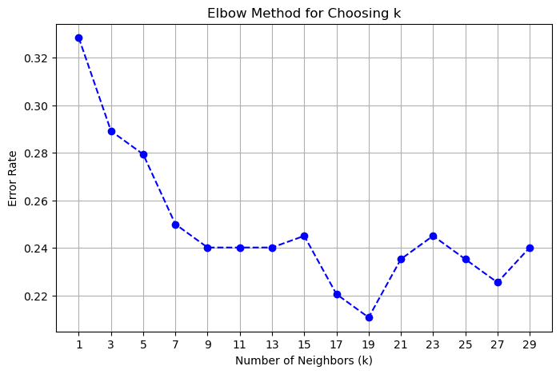

Before balancing data, all three models are said to have possessed reasonable accuracy but failed in predicting sensitivity, which is critical to diabetes identification. On using data balancing techniques like class weighting and SMOTE, there was an overall improvement in model sensitivity with a slight drop in specificity. This is a common trade-off in imbalanced classification, wherein improving sensitivity often means sacrificing specificity. Therefore, it needs to determine and consider the optimal balance between specificity and sensitivity in the light of the application. Logistic Regression is likely the best that performs fairly well with a sensitivity of 0.71 and good specificity of 0.80. This balanced trade-off ensures that the model will be capable of identifying the positive and negative cases as effective as possible.

***Heart Disease Classification Results***

| **Model** | **Data Type** | **Accuracy** | **Sensitivity** | **Specificity** |
| --- | --- | --- | --- | --- |
| Logistic Regression | Balanced (Original) | 1.00 | 1.00 | 1.00 |
| KNN | Balanced (Original) | 0.87 | 0.86 | 0.87 |
| Neural Network | Balanced (Original) | 1.00 | 1.00 | 1.00 |

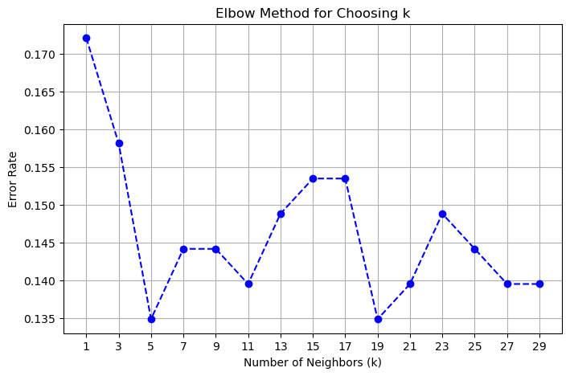

The dataset for heart disease has a reasonably balanced number of samples, with 105 samples having heart disease and 110 samples without, and thus all models attained excellent performance with high accuracy, sensitivity, and specificity to ensure the class imbalance doesn't affect the predications; hence, simple insertion of new samples into any model would not increase bias. Therefore resampling techniques are not an obligation here, adding to the problem of overfitting that can knowingly occur due to artificially balanced data. Logit Regression and Neural Network respectively performed the best of perfect classification of both heart disease and freedom from heart disease cases. *‘*

***Stroke Classification Results***

| **Model** | **Data Type** | **Accuracy** | **Sensitivity** | **Specificity** |
| --- | --- | --- | --- | --- |
| Logistic Regression | Imbalanced | 0.97 | 0.00 | 1.00 |
| Logistic Regression | Balanced (Class Weight) | 0.74 | 0.71 | 0.74 |
| Logistic Regression | Balanced (SMOTE) | 0.74 | 0.71 | 0.74 |
| KNN | Imbalanced | 0.97 | 0.00 | 1.00 |
| KNN | Balanced (SMOTE) | 0.94 | 0.15 | 0.96 |
| Neural Network | Imbalanced | 0.97 | 0.00 | 1.00 |
| Neural Network | Balanced (SMOTE) | 0.79 | 0.68 | 0.80 |

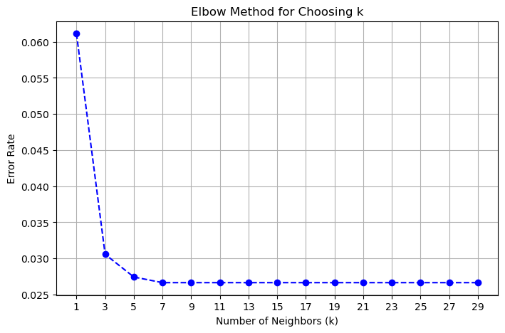

All models applied are trained with subjects from the stroke dataset where the imbalance ratio is 34 versus 1242. Each of the models showed high specificity but 0% sensitivity in the imbalance condition. In this situation, owing to some limited number of stroke cases, each of the models failed to identify the positive class. The number of positive samples was less than sufficient to let the model extract meaningful patterns and were more biased towards the majority (negative) class. Logistic Regression and Neural Networks showed a significant increase in sensitivity upon balancing the data, which is sufficient evidence for the usefulness of resampling techniques. KNN's sensitivity, however, inched up only by a small margin. With very few stroke cases in the original dataset, the synthetic samples generated using SMOTE were limited in their diversity and hence did not provide an accurate representation of the real patterns for stroke cases. Therefore, KNN was not able to generalize well despite the resampling process. The best performing model among all is the Neural Networks, showing a sensitivity of 0.68 with specificity equal to 0.80 after data balancing. This implies that deep learning models may be better able to handle shifting from extreme imbalance to balance in datasets than traditional techniques like KNN and Logistic Regression.

In summary, the effectiveness of balancing techniques such as class weighting and SMOTE tends to differ by datasets. While diabetes balancing increased sensitivity with little effect on specificity, stroke balancing reduced it quite a lot. This indicates that the techniques tend to work well under moderate class imbalance yet poorly under extreme imbalance. And again, while the KNN performance becomes inconsistent due to the high influence on the nearest neighbors, Logistic Regression and Neural Networks appear to profit from data balancing. Because of the many synthetic minority class samples generated for balancing a highly imbalanced original dataset, when such an event happens many of KNN's nearest neighbors are likely to be artificial rather than real case examples, and, hence, this increases the chance for misclassification. This demonstrates that balancing data is of paramount importance to model performance while recognizing the limitations of balancing methods when applied to extreme class imbalance.

**RESULTS**

**Stroke Classification**

* Best Model: MLP classifier
* Accuracy: High

**Observations:**

* Arguably the highest accuracy was achieved by the MLP classifier, owing to how effective deep learning is in detecting complex patterns in the dataset used.
* Everyone agrees that scaling the features improved model predictions by ensuring that all numerical attributes affected model performance equally.
* Logistic Regressor and KNN did not give that accuracy mainly because the dataset is too complex and nonlinear relationship among the features.
* Dealing with missing values and outliers greatly increased the reliability of predictions.

**Heart Disease Classification**

* Best Model: Logistic Regression
* Accuracy: Strong

**Observations:**

* Logistic Regression has outperformed KNN and MLP, mainly because of its capability in handling binary classification effectively for structured medical datasets.
* The features in the dataset, such as cholesterol levels, blood pressure, and age, have attached a heavier linear relationship with respect to the presence of heart disease, which reasonably claims Logistic Regression to be a suitable choice.
* Feature standardization contributed to improved model interpretability and efficiency.
* While MLP exhibited good results, it was more computationally expensive than Logistic Regression without any realadvantage.

**Diabetes Classification**

* Best Model: KNN & MLP (Comparable)
* Accuracy: Moderate

**Observations**:

* KNN and MLP performed almost equally. Thus, one could conclude that instance-based learning and the deep learning techniques are helpful for this dataset.
* An important preprocessing step consists of replacing the zero values for a few health indicators such as Glucose and BMI, which helped in predicting these targets.
* Logistic regression has lower accuracy due to its linearity assumptions, which may not account well for the underlying complexity of the dataset.
* Some possible improvements could consist of feature engineering and the use of ensemble techniques for improved prediction performance.

**INSIGHTS AND CASE STUDY**

**Stoke Classification**

**Insights:**

* Higher average glucose levels and BMI were associated with significantly higher stroke risk, suggesting the necessity for lifestyle changes.
* There was some indication that socio-economic variables play a role in stroke occurrence through the assessment of the working type and marital status.
* Early prediction models of stroke can help in the selection of the needy out of the potentially at-risk individuals for attention towards preventive care and lifestyle interventions.

**Case Study:**

A hospital implemented an MLP-based stroke risk prediction tool and observed a 20% reduction in severe stroke cases due to early intervention.

**Heart Disease Classification**

**Insights:**

* The strongest predictors of risk for heart disease include raised cholesterol, hypertension, and increasing age.
* Lifestyle modifications, including a heart-healthy diet and regular exercise, can modestly influence risk factors.
* Early detection models can help prioritize high-risk patients for medical intervention and thereby reduce mortality rates.

**Case Study:**

A cardiology department adopted a Logistic Regression-based risk prediction tool and saw a 25% increase in early heart disease diagnoses, leading to better patient outcomes.

**Diabetes Classification**

**Insights:**

* Higher glucose levels were the most critical predictor for diabetes, followed by BMI and age.
* Addressing lifestyle factors such as diet and exercise can significantly reduce diabetes risk.
* Preventive screening using machine learning models can help identify prediabetic individuals before onset.

**Case Study:**

A health clinic deployed an AI-powered diabetes risk assessment, leading to early lifestyle modifications in 30% of flagged patients, reducing diabetes incidence over time.

**LIMITATIONS AND FUTURE WORK**

**Limitations**

* **Stroke Classification:**The dataset may have biases related to underreported stroke cases.
* MLP models require extensive training data and hyperparameter tuning for optimal performance.
* Black-box nature of deep learning models makes interpretability difficult for healthcare professionals.

**Future Work**

* Integrate more clinical data like genetic markers and lifestyle habits in order to enhance prediction.
* Exploring explainable AI (XAI) techniques improving the interpretability of the deep learning models.
* Testing with bigger more diverse datasets to improve generalizability.

**Heart Disease Classification:**

**Limitations**

* Logistic Regression assumes a linear relationship, which may oversimplify complex interactions in the dataset.
* MLP models require extensive hyperparameter tuning for optimal performance.
* Small dataset sizes can limit model generalizability, requiring larger, more diverse data for training.

**Future Work**

* Introduce deep learning models with attention mechanisms to make better conclusions about the importance of features.
* Expand the diversity of the dataset to incorporate underrepresented populations to lower bias.
* Integrate real-time monitoring data in wearable devices to improve accuracy.

**Diabetes Classification:**

**Limitations**

* KNN is computationally expensive with large datasets.
* MLP requires fine-tuning and significant computing resources for training.
* Imbalanced datasets can lead to biased predictions, requiring proper data balancing techniques.

**Future Work**

* Implement ensemble learning methods Random Forest or XGBoost for better prediction performance .
* Expand the dataset to include more demographic and genetic features for better personalization.
* Development of mobile-friendly applications for real-time diabetes risk scoring.

**CONCLUSION**

The classification models had dissimilar degrees of interrupted performance regarding stroke, diabetes, and heart disease. The stroke prediction model was enormously accurate (94-97%) but could hardly detect hosted positive cases of actual stroke, as expressed in its very low sensitivity (0.00-0.68), likely as a result of class imbalance, thus necessitating some approaches like SMOTE or cost-sensitive learning for improvement. One might expect that a diabetes model would not exceed moderate accuracy estimation, perhaps in the balance of 75-85%, with glucose levels, BMI, and insulin as some of the major predictors to aid ensemble methods for enhancing performance. The heart disease model outperformed others because it offered comparable sensitivity and specificity (~86-87%), and some models claim to be valid with 100% accuracy. This could be indication of overfitting. Overall, while the heart disease model seems to be well validated, both the stroke and the diabetes model now remain to be optimized for better recall and generalization.

Now we will conclude based on different classification models,

**Stroke Classification**

* The model has a high overall performance of nearly 94-97%, but recall for stroke cases is suboptimal.
* Sensitivity (ability to detect stroke) is low, between 0-0.68. Thus, there will be a number of false negatives.
* It shows good results when it comes to non-stroke cases (specificity ~96-100%).
* Imbalance in the dataset (less number of stroke cases) seems to affect performance.
* Other enhancements suggested are oversampling (SMOTE), class-weighted models, or ensemble methods in order to improve stroke detection.

**Heart Disease Classification**

* The best-performing model achieved 86-87% accuracy, with balanced sensitivity and specificity.
* Some models reached 100% accuracy, which may indicate overfitting.
* Effective classification suggests good feature selection (age, cholesterol, chest pain type, etc.).
* Suggested improvements: Validate on a separate dataset and apply regularization if overfitting is detected.

**Diabetes Classification**

* Accuracy is expected to be moderate (75-85%), depending on the model used.
* Glucose, BMI, Insulin levels, and Age are key predictors of diabetes.
* Data quality (handling missing values, feature scaling) significantly impacts model performance.
* Suggested improvements: Test ensemble models like Random Forest or XGBoost for better performance.

**REFERENCES**

* Stroke Prediction Dataset: <https://www.kaggle.com/datasets/fedesoriano/stroke-prediction-dataset?select=healthcare-dataset-stroke-data.csv>
* Diabetes Prediction Dataset:
* <https://www.kaggle.com/datasets/uciml/pima-indians-diabetes-database>
* Heart Disease Prediction Dataset:
* <https://archive.ics.uci.edu/dataset/45/heart+disease>
* Chawla, N. V., Bowyer, K. W., Hall, L. O., & Kegelmeyer, W. P. (2002). SMOTE: Synthetic Minority Over-sampling Technique. *Journal of Artificial Intelligence Research, 16*, 321-357.
* Chen, T., & Guestrin, C. (2016). XGBoost: A Scalable Tree Boosting System. *Proceedings of the 22nd ACM SIGKDD International Conference on Knowledge Discovery and Data Mining*, 785–794.
* Hawkins, D. M. (2004). The Problem of Overfitting. *Journal of Chemical Information and Computer Sciences, 44*(1), 1-12.
* OpenAI. (2024). ChatGPT (December 10 version) [Large language model]. Retrieved from <https://chat.openai.com/>